POWER LEARN PROJECT WEEK 2 ASSIGNMENT 1

INSTALLATION OF MySQL, DART, FLUTTER AND DJANGO

Firstly my main issue is the fact that I had to research how to download all these applications by myself because not many people are using MacOS in the class but I still feel like its unfair because for this whole week I couldn’t follow along with anything so it was like a waste of data for me because I couldn’t do anything other than wait for the instructors to do slides.

INSTALLING MySQL

So I was able to install MySQL but then I had issues starting the application from the system preferences app

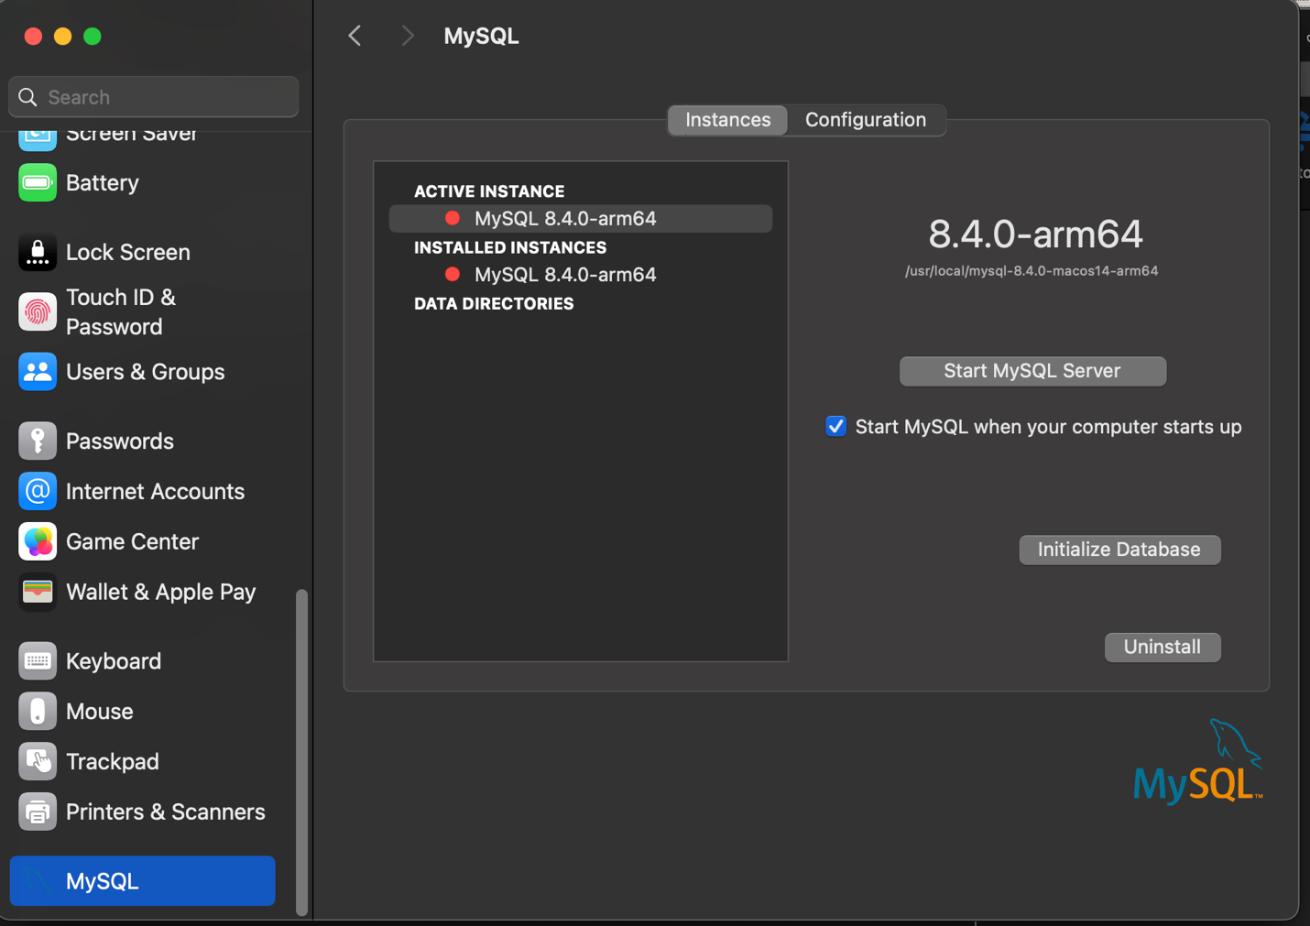

So I tried some solutions out suggested by ChatGPT until I found one that worked .

Firstly, I tried to check the MySQL logs on my mac but that didn’t work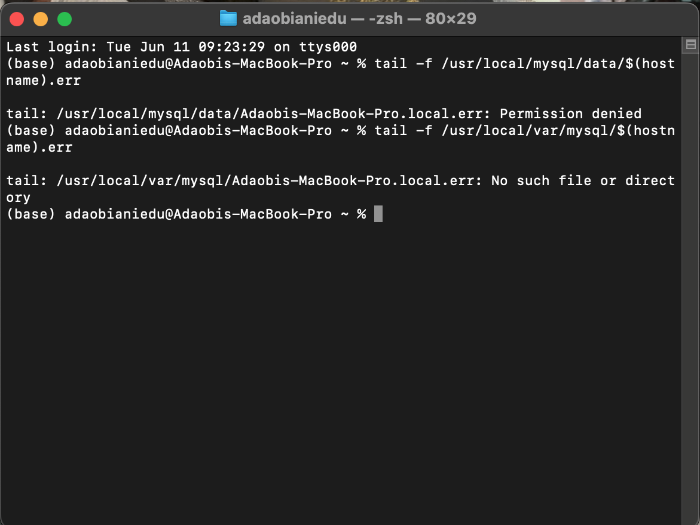

Then I tried ensuring that I had the proper permissions to use the application which also didn’t work.

So finally I tried manually starting the application using this code : ***sudo /usr/local/mysql/support-files/mysql.server start*** and it finally worked .

INSTALLING DART AND FLUTTER

I was unfortunately unable to download flutter and dart because in other to download it I needed to use the package manager called Home brew and unfortunately it doesn’t work for the model of Mac that I have

